**MAKE SBIR/STTR PERMANENT**

*1156 15th St NW*

*Suite 502*

*Washington, DC 20005*

[*www.sbtc.org*](http://www.sbtc.org)

*Robert Schmidt*

*Kevin Burns*

*Co-Chairmen*

*Jere Glover*

*Executive Director*

*Larry Nannis*

*Treasurer*

*Matt Oristano*

*Joseph Schwartz*

*Mid-Atlantic*

*Regional Chair*

*Ash Thakker*

*Southeast*

*Regional Chair*

*Mary Delahunty*

*Southwest*

*Regional Chair*

*Russ Farmer*

*Mountain*

*Regional Chair*

*Michael Browne*

*Pacific*

*Regional Chair*

*Roy Keller*

*State Liaison*

*Paul Donovan*

*Michael Squillante*

*NIH Committee*

*Co-Chairs*

*Ash Thakker*

*Phase III Committee*

*Chair*

*Russ Farmer*

*DCAA Committee*

*Chair*

***The Best Return for the Taxpayer Dollar***

As Congress considers SBIR/STTR reauthorization, it is important to understand how uniquely successful these innovative R&D programs have been.

The small percentage of DOD R&D funding that is invested in the SBIR program is producing outsized returns. SBIR/STTR Economic Impact Studies for the DOD and NCI have shown the remarkable impact that these programs have had on the American economy. These include economic returns in excess of $15 to $23 for every dollar spent,[1] in addition to improved military strength and capability, significant cost-savings, further economic impacts from new industries with new products and services, new life saving medical techniques and products, and added sales and profits (not counted in the studies) at other companies from acquisitions of the new technology businesses and licensing of their new technologies.

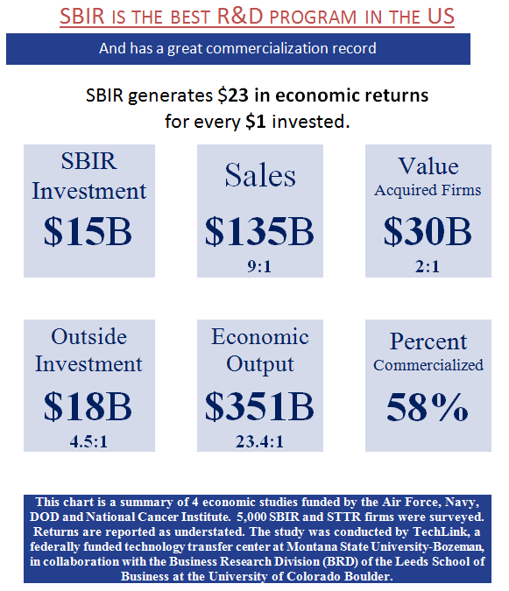

Furthermore, a recent National Cancer Institute study into the economic impacts of the SBIR/STTR program showed that there is a **$3.80 return in tax receipts for every $1 dollar invested into the SBIR/STTR program**. Thus, SBIR not only creates good paying American jobs and keeps the US ahead of China, Europe, and the rest of the world technologically; it acts like a printing press to create new money.[2]

The SBIR/STTR program invests a small fraction of Federal R&D in small business and entrepreneurial energy to solve Federal agency mission challenges. The program is highly competitive (with only 1 in 20 proposals reaching Phase II), awarding some 3.2% of Federal extramural R&D to small businesses (in comparison with small business employing around 1/3 of the nation’s scientists and engineers).

In 2018, the Section 809 panel, which was tasked with finding ways to streamline and improve acquisition at the DOD, released a report offering its recommendations. After praising SBIR for generating “positive outcomes for participants and the government” and creating a direct connection between innovative technology companies and the acquisition community, **the 809 Panel recommended more than doubling the SBIR allocation, to 7%, and making it permanent**.[3]

The Small Business Technology Council (SBTC) urges Congress to adopt these and other changes in the upcoming SBIR/STTR reauthorization bill.

**SBTC SBIR/STTR Reauthorization Recommendations**

1. *Make SBIR/STTR permanent*
2. *Increase SBIR allocation increase to 7%*
3. *Increase STTR allocation to 1%*
4. *Require agencies to set goals for Small Business R&D*
5. *Support the Rapid Innovation Fund (RIF)*
6. *Require updates of FAR and DFAR regulations*
7. *Require agencies to use 1/3 of 3% Admin funds for streamlining, training, & goaling*
8. *Require agencies to publish reports & data in a timely manner*
9. *Don’t weaken SBIR/STTR selection criteria that focuses on merit*
10. *Expedite Security Clearances for SBIR/STTR firms*
11. *Support the STRONGER Patents Act*

*The Small Business Technology Council (www.SBTC.org) is the nation’s largest association of small, technology-based companies in diverse fields. SBTC advocates on behalf of firms who participate in the Small Business Innovation Research (SBIR) and Small Business Technology Transfer (STTR) programs.*

**Unlock SBIR/STTR’s Full Potential**

***1) Make SBIR/STTR permanent***

The SBIR program has a proven, successful track record for nearly 40 years, and STTR for nearly 30 years. Multiple economic impact studies as well as over a dozen NAS studies have been conducted over the decades that have proved the programs innovation and unparalleled productivity of American small business skill, hard work, and entrepreneurship. The time has come to make the programs permanent to enable the sustained investment and returns that come from longer term perspectives.

***2) Increase SBIR allocation increase to 7%***

Follow the Section 809 Panel’s recommendation to double the SBIR allocation to further unleash high-tech small business’ innovative and economic potential. Small Businesses generate 25% of key innovations despite receiving only 3.2% of federal R&D budget. SBIR has proven to be more successful than any innovation program in the government, and should be given greater investment.

***3) Increase STTR allocation to 1%***

STTR has shown to be successful, but at only 0.3% of the federal extramural R&D is simply too small to make a difference. Increasing the allocation to 1% will facilitate greater collaboration between universities generating next generation basic research and innovative small businesses who can translate that research into commercializable technologies.

***4) Require Agencies to set goals for small business R&D prime contracting***

Agencies are currently required to award 23% of their contracts to small business. As small business employs 1/3 of all scientists and engineers, every agency should set goals for awarding prime contracts to small business for Research and Development that is not less than 16.5% of their total extramural R&D budget.

***5) Support the Rapid Innovation Fund (RIF)***

RIF has been the primary way of funding Phase III testing and evaluation. The RIF should be funded with at least $1 billion in 2022. This can be through an appropriation, or by requiring a percentage of external R&D be set aside for RIF.

***6) Require updates of FAR and DFARS regulations***

Congressional changes to the SBIR/STTR law are often not implemented because of the the FAR and DFARS are not updated in a timely manner to reflect the changes. The FAR and DFAR regulations have not been updated to reflect new laws in the past decade, resisting Congressional action to improve and speed technology advancement. SBTC recommends a requirement in the law that the FAR, DFARS, and other procurement policies and procedures be updated and reconciled with the law within one year for SBIR/STTR statutory changes.

***7) Require agencies to use 1/3 of 3% Admin funds for training, goaling, and streamlining contracting procedures***

The provision allowing agencies to use 3% of their SBIR/STTR set-aside for administration was done, in part, to help speed up contracting and encourage transition. Yet insufficient training of contracting officials and delays in contracting still persist, slowing SBIR’s innovative potential. Additionally, incentives for military officials making Phase III SBIR awards was authorized in a prior NDAA, but has yet to be implemented. SBTC recommends requiring agencies to use 1/3 of their 3% admin funds for a) training of contracting officials, b) expediting and simplifying SBIR/STTR contracting processes, and c) setting goals and incentives for Phase III contracts

***8) Require Agencies to publish required reports and data on their website when it is provided to SBA or DOD.***

Congress can’t properly evaluate the changes made to the SBIR/STTR program without timely and relevant data and reports. SBA often falls 2 to 3 years behind in releasing their reports to Congress on the program. To speed up the process and improve SBIR/STTR program transparency, agencies should be required to publish their data and reports on their website when it is sent to SBA.

***9) Don’t weaken SBIR/STTR selection criteria that focuses on merit***

SBIR/STTR works because the technologies selected for funding are based on science and merit. While there is need for greater participation for companies from underserved states and women/minority-owned businesses, that should be addressed through greater outreach, education, and mentoring programs. Introducing requirements that would move award selection away from the best science degrades SBIR/STTR’s success and make it more difficult for agencies to fulfill their missions.

***10) Expedite Security Clearances for SBIR/STTR firms***

Small companies are the next generation of defense contractors. To grow the defense industrial base, lower cost with greater competition, and bring the best ideas to DoD strengthening the warfighter, it is important to enlarge the pool of potential defense contractors. The Small Business Innovation Research (SBIR) and Small Business Technology Transfer (STTR) programs continually develop new ideas to make our warfighting capacity better. However, many of these SBIR/STTR contractors are prohibited from bringing their prototypes to the field because they do not have security clearances. Therefore, to allow more SBIR/STTR firms to attend classified conferences, bid classified programs, and make America’s industrial base more competitive, DoD should allow SBIR/STTR firms to apply for security clearances without a previously cleared company sponsor or Government Sponsor. DOD shall prioritize investigations and granting security clearances to SBIR/STTR firms.

***11) Support the STRONGER Patents Act***

America has now fallen from #1 to #11 in innovation.[4] Lack of injunctions and weak patent laws are inhibiting SBIR/STTR firm’s growth. Stronger patents will improve the innovation ecosystem. Further, the US is now ranked #16 for protecting design rights, behind countries like Greece, Spain, and Turkey.[5]

1. Techlink, 2018: “National Economic Impacts from the Air Force and Navy SBIR/STTR Programs, 2000-2013”
2. US Department of the Navy: “SBIR/STTR By the Numbers”, 2018
3. DOD Section 809 Panel, Jan. 2018: “Report of the Advisory Panel on Streamlining and Codifying Acquisition Regulations”, Sub recommendation 21b.
4. # South Korea Leads World in Innovation as U.S. Exits Top Ten, <https://www.bloomberg.com/news/articles/2021-02-03/south-korea-leads-world-in-innovation-u-s-drops-out-of-top-10>, Feb 2, 2021.

  
5. U.S. Chamber of Commerce’s Global Innovation Policy Center, International IP Index, 2021 Ninth Edition, <https://www.theglobalipcenter.com/wp-content/uploads/2021/03/GIPC_IPIndex2021_FullReport_v3.pdf>, pg. 12.