**SBIR** is the best commercialization program in the **US**

SBIR generates **$14.7 in economic returns** for every **$1** invested.

Well over half of the Air Force and Navy Phase II contracts – 60% – resulted in sales of new products and services based on the innovations developed with these contracts. Companies reported the following direct commercialization-related outcomes from their Phase II contracts:

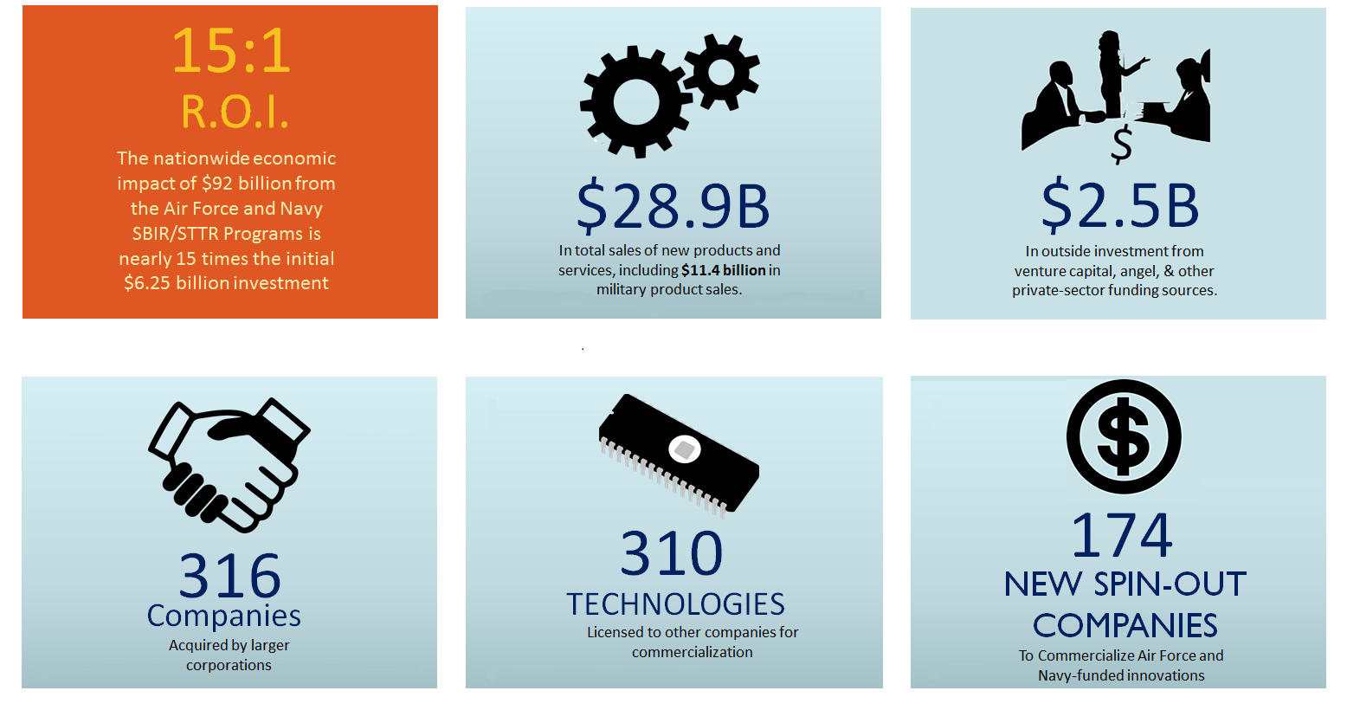The research teams used IMPLAN economic-impact assessment software to estimate the total economic impacts related to both the $6.25 billion in Air Force and Navy Phase II contracts and the subsequent $28.9 billion in sales of new technologies. Results included:

**$92.1**B **Total economic output nationwide** **$46.9**B **In value added, nearly 8X the SBIR/STTR Investment**

**$29.8**B **In labor income 31,724** **Average new full-time jobs per year c**

These studies were commissioned by the Air Force and Navy SBIR/STTR Programs. They were the first comprehensive studies of the economic impacts of federal SBIR/STTR programs. Both were conducted by TechLink, a federally-funded technology transfer center at Montana State University-Bozeman, in collaboration with the Business Research Division (BRD) of the Leeds School of Business at the University of Colorado Boulder.

The Air Force and Navy SBIR studies found, after surveying 95.7% of all Phase II winners between 2000 and 2013, that 29% of awardees have had sales in excess of $1 Million. Seven contracts resulted in sales of over $500 million, 46 had sales of over $100 million, 464 companies had sales of over $10 million and 2,070 contracts had sales of over $1 million.