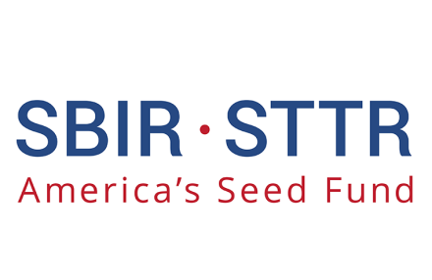

***Company Name/logo***

**Address**

**Website/other Contact info**

Name of Technology

## *Subtitle/brief description of technology*

Please include a brief narrative of your companies technology developed with help from SBIR/STTR programs. Include the challenge/problem it was meant to address, what the technology does and how it works, and how SBIR/STTR funding helped your company develop the technology. Please be concise, use lay terminology, and focus on economic outputs like jobs created and revenue generated.

***ECONOMIC IMPACTS***

**AGENCY**

**Office/Mission/Directorate**

* **List Phase I/Phase II awards received, dollar amount**
* **List economic impacts of successful SBIR/STTR technology**
* **Include jobs added, revenue generated, follow-on funding, patents, mergers, acquisitions, or spinoffs that resulted**
* **Summary of Return on Investment**

This space can be used for charts, logos, pictures, or additional text.